**COMSAT UNIVERSITY ISLAMABAD ATTOCK CAMPUS**



**INFORMATION SECURITY**

**NAME: MENAHIL NOOR**

**REGISTRATION NO: SP24-BSE-035**

**ASSIGNMENT: 01**

**DEPARTMENT: SOFTWARE ENGINEERING**

**DATE: 11 OCTOBER 2025**

1. **Write python code for your designed stream cipher approach for encryption decryption, you can use approach from more than one already developed ciphers as given in lab practice exercises.**

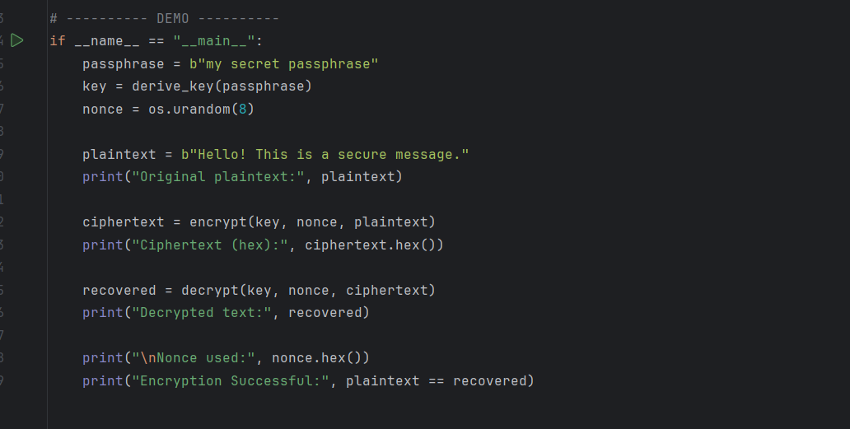**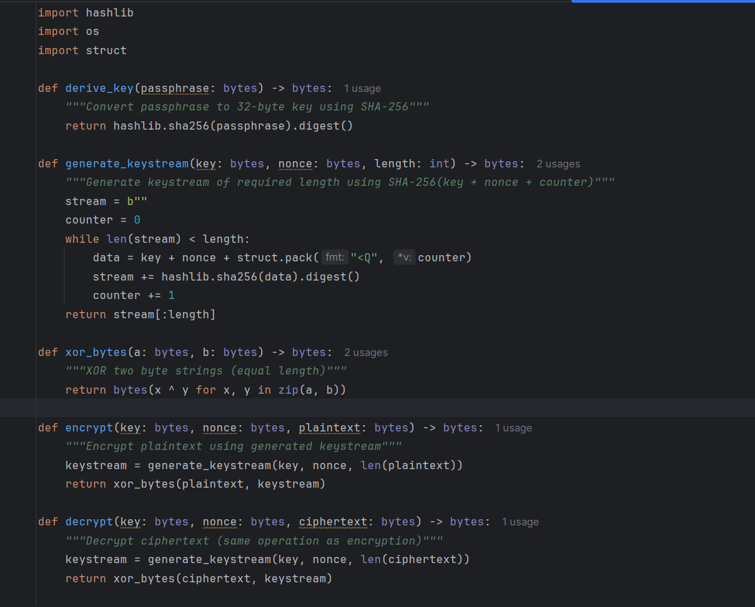CODE:**

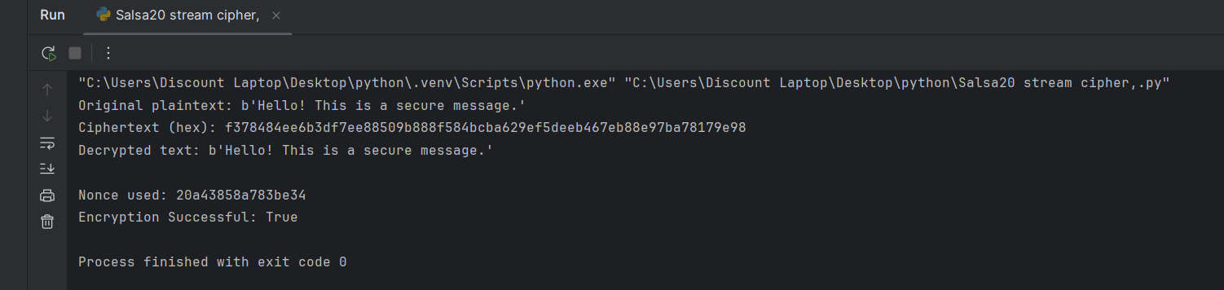**OUTPUT:**

1. **Design and implement an adversarial attack approach for your proposed stream cipher approach.**

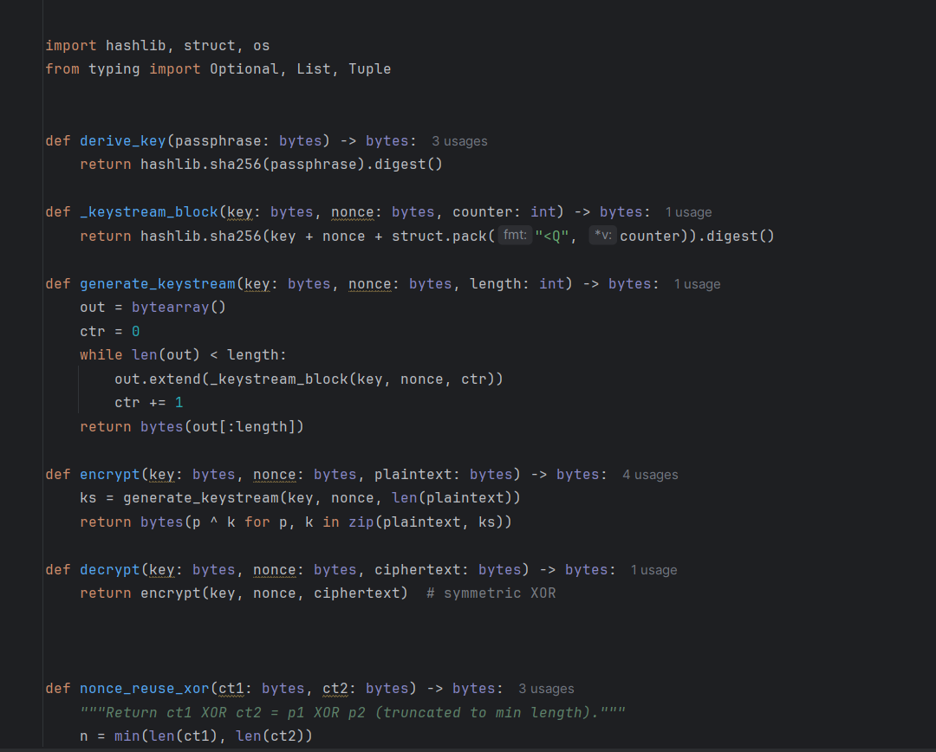**CODE:**

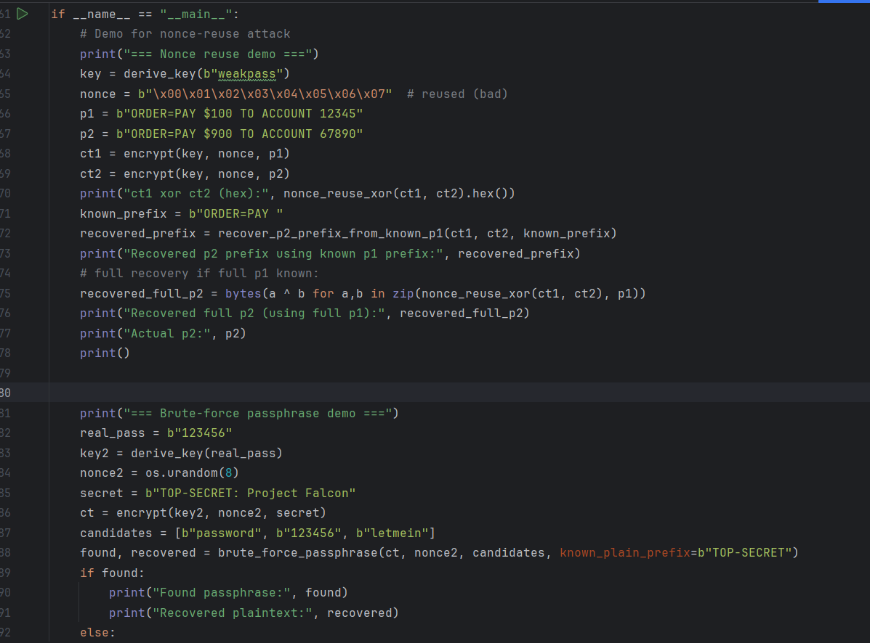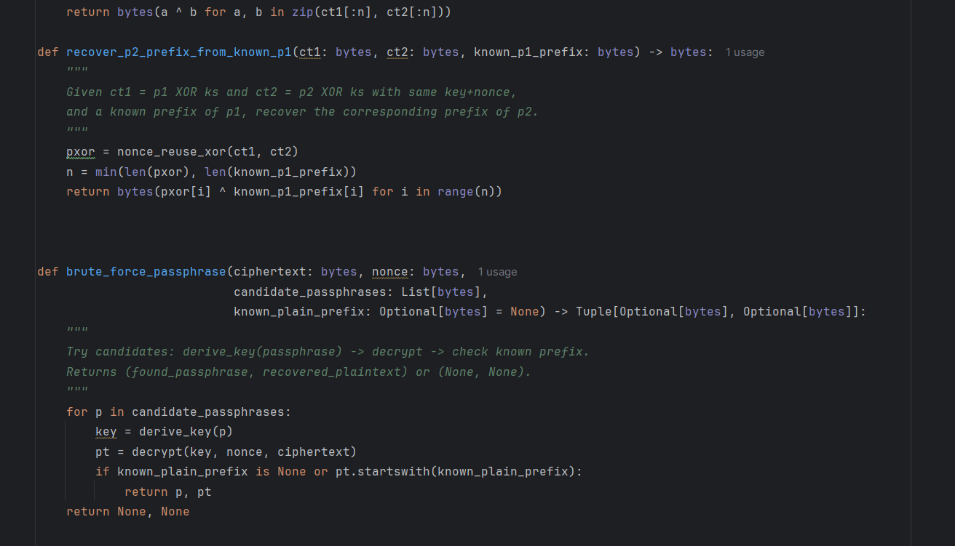

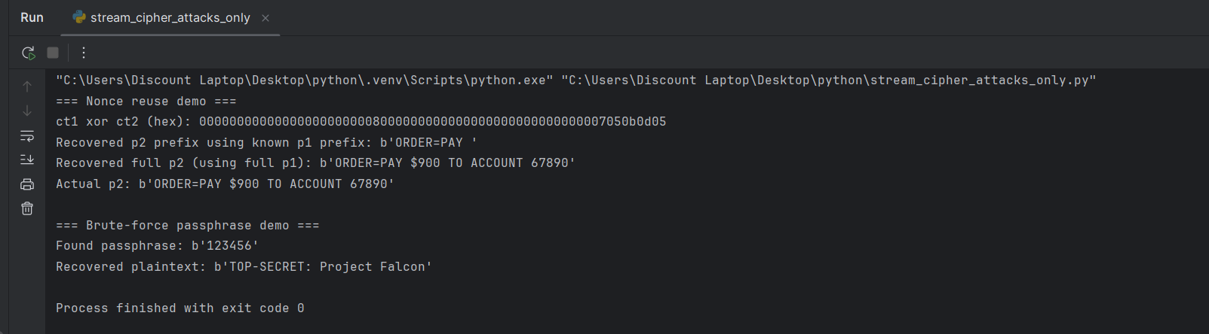**OUTPUT:**